At this point we have created so many packages like:
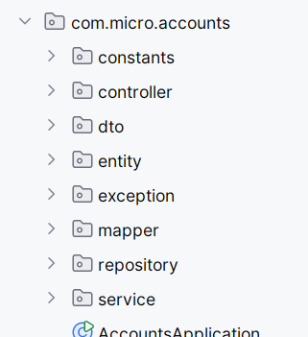
Inside constants we have a class which where there are only constant string values and that class has a private constructor so that no other class can create a object of that class.
In controller layer we have AccountsController which is responsible for accepting the payload from frontend in the form of a CustomerDto object and will help in creating a new customer as well as account in the DB. It injects the bean of the type AccountsServiceImpl which is a service class or implementation class of the IAccountsService interface.
Our controller is designed in such a manner that if everything is good then it will return a ResponseEntity which basically carrier a HttpResponse having both body and status code.
We can see we are calling the 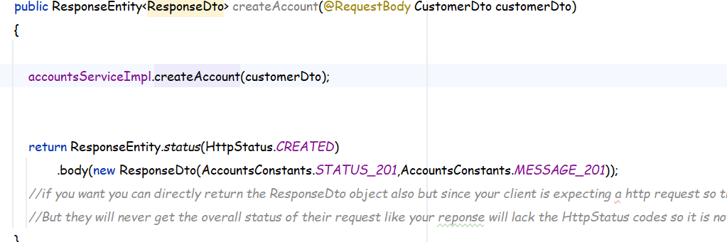
createAccount method of the accountsServiceImpl bean and passing the customerDto to it.
Now if you check inside the createAccount method then we are calling the mapper function of the CustomerMapper class to map the customerDto object with a new Customer Entity object for using it directly in the Repository class.
The Mapper Classes are having static functions inside them which are used just like some utility class functions.
Once the mapping is done it returns us a Customer object then using that object we call a custom function of the customerRepository class to check if a customer exists with the current mobileNumber or not , if it exists then we are throwing a custom exception of type 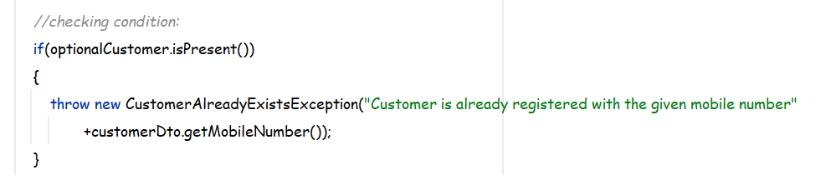
And this exception will be handled by the global exception handler.
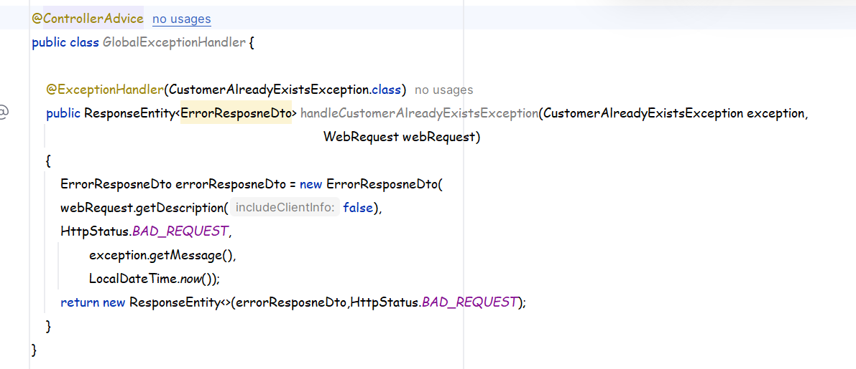
Here we have also created a method specifically to handle exceptions of type CustomerAlreadyExistsException and then we will return a object of type ErrorResponseDto in the RepsonseEntity and have a look at the RepsonseEntity and it’s fields and you can understand why are we calling the AllArgsConstructor of the ErrorResponseDto and and what are we passing as parameters then once the object is created we will return a new object of type ResponseEntity as can be seen and all this information will be given to the caller or end user.

But if there are no exceptions then the code proceeds smoothly in the AccountsServiceImpl class and then a object of type Customer is created and then registered also and also the private function createNewAccount gets called and account is also created in the DB as per the code then finally our service returns to the controller layer and from there it returns a ResponseEntity as follows:
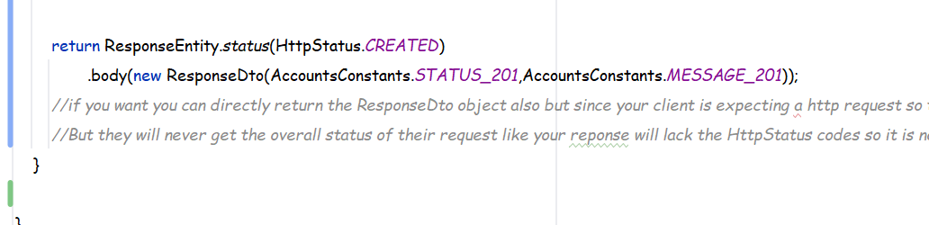

Tests:
In Postman :
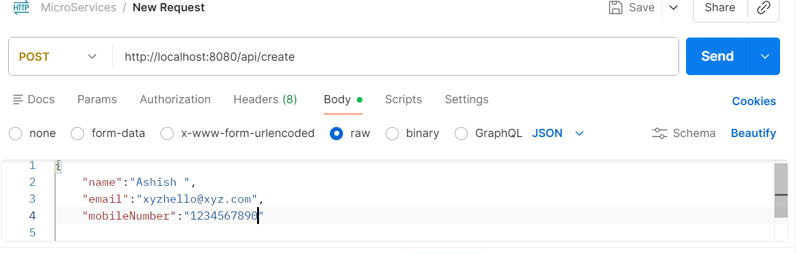
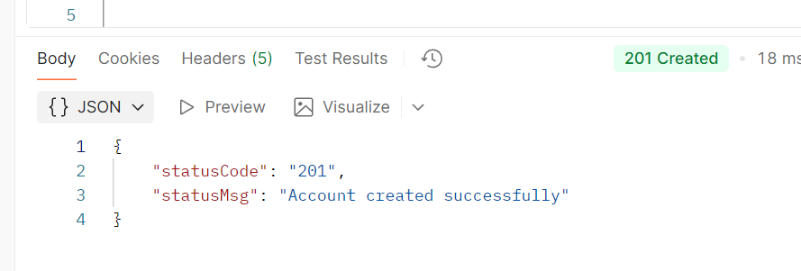
If we again send the above info then we get:
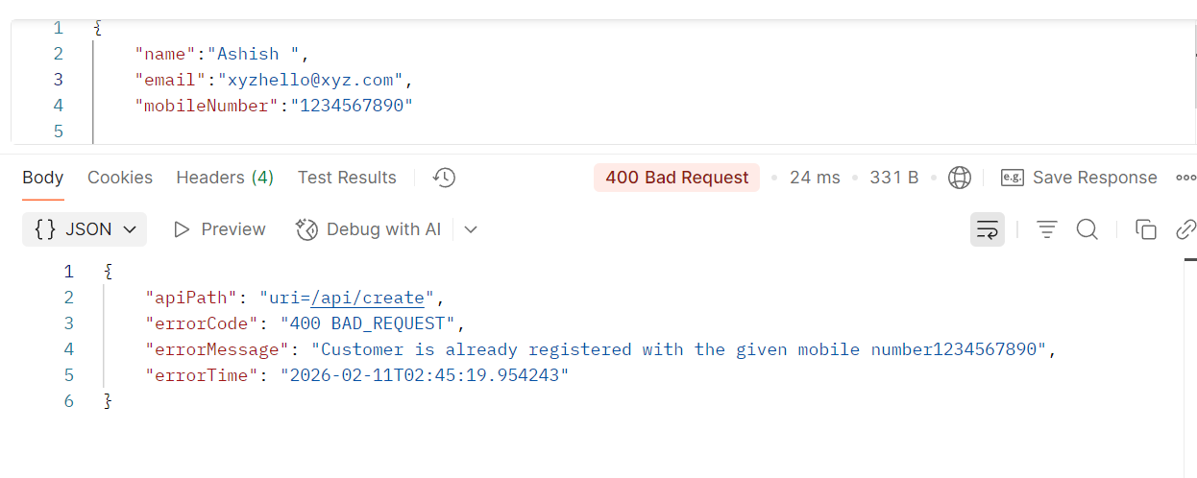
This exception;

Validations :
How can we validate the data that we have received as a input from the end user.
For this we need to install a dependency that is 
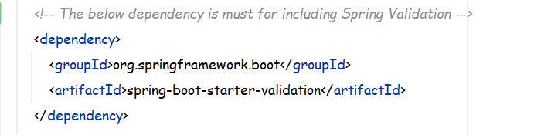

Now after installing this we need to make some changes in the DTO’s which are responsible for receiving the ResponseBody
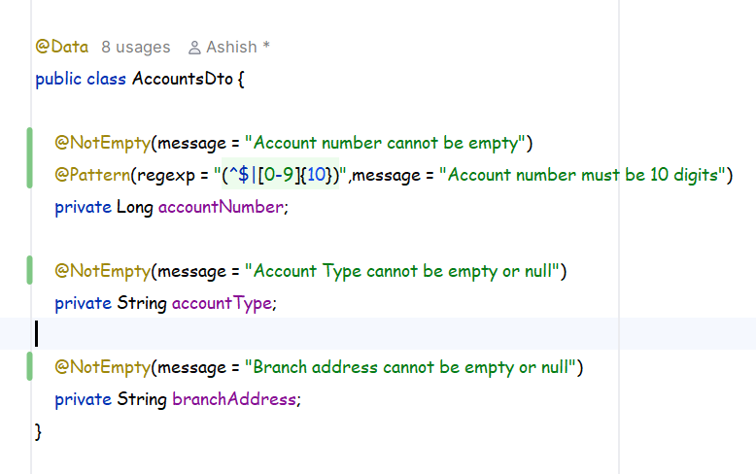
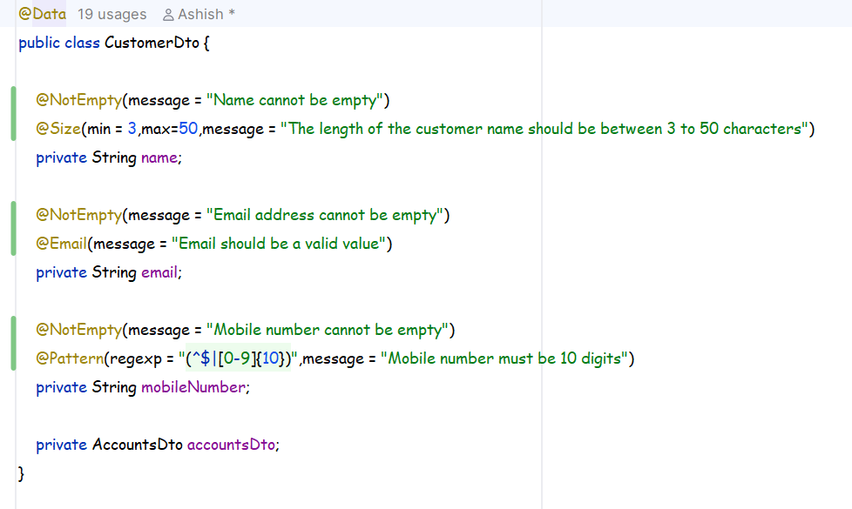
Now we have mentioned the criteria of the DTO like which field expects what but validation is still not applied on top of it , it will only be applied wherever we are creating or passing the DTO object with annotating it with @valid .
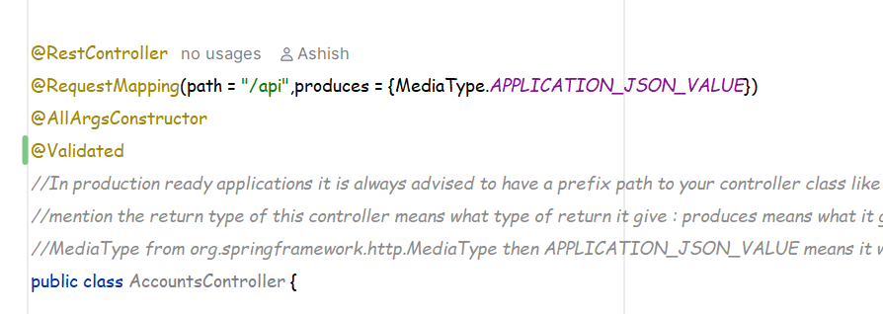
We need to write @validated on top of our controller class to let it know that we have to validate each and every api inside it but also only if we are using @valid in the api method parameter .
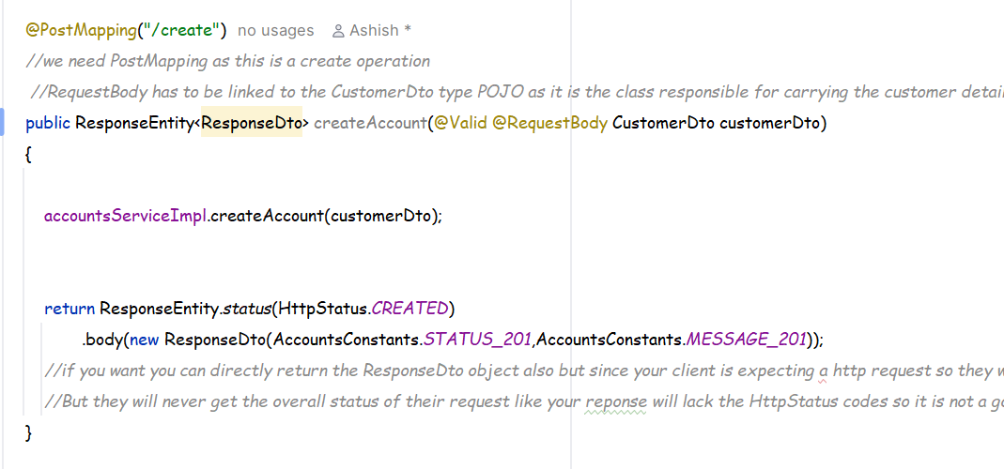
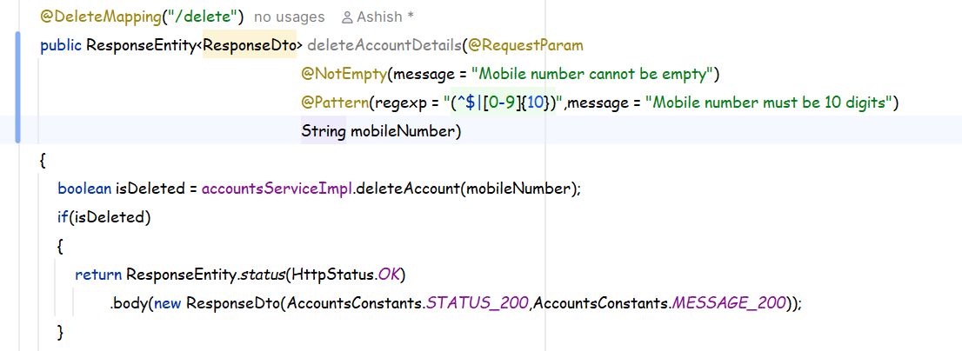

Now we have mentioned all the messages that our code is suppose to display when the validation fails but how to send that message as a response it is not yet done , so for this we will have to handle the exceptions in the globalExceptionsHandler.
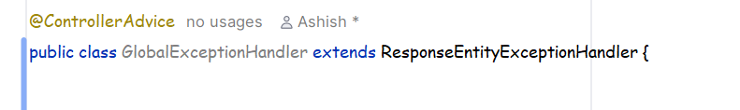
Extend the above class and inside that class there is one function we need to override that, that class will carry all the information’s regarding to the Validations.
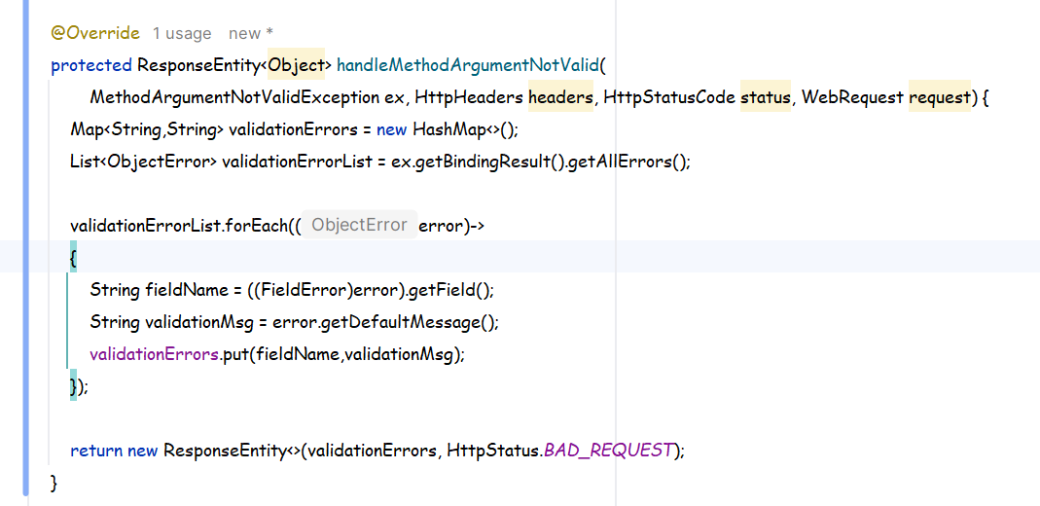

Example:
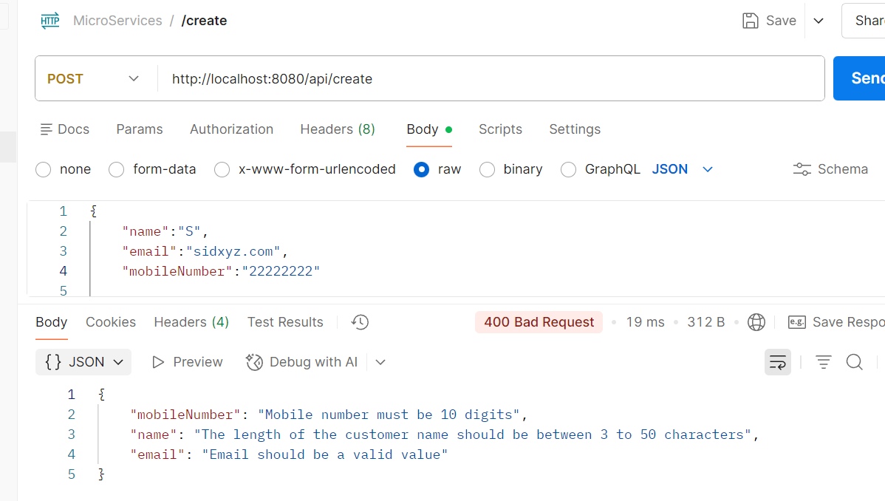

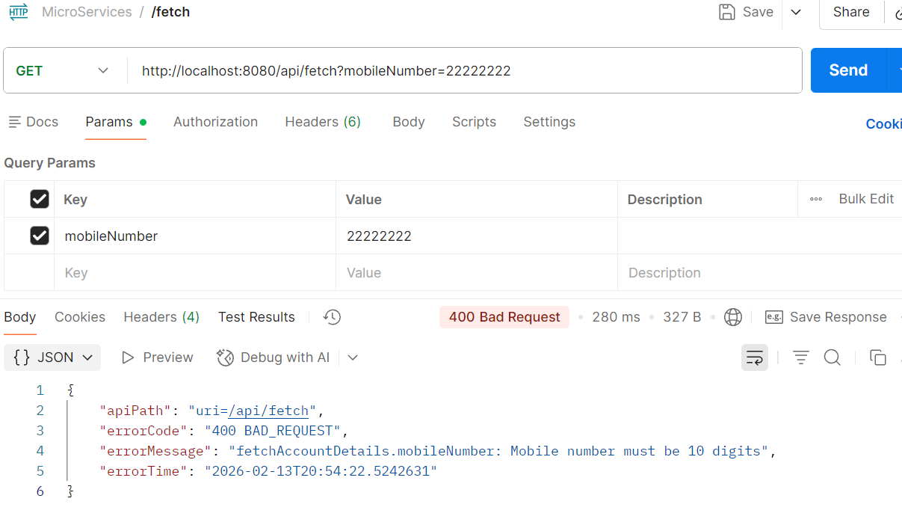
For the fetch function the returned JSON is looking different because it is handeled by the handleGlobalException function.

